|  |  |  |  |
| --- | --- | --- | --- |
| 1 | | 9,767.57142857143 | |
| NUMERO DE FRONTERAS | | ENERGIA AGREGADA | |
|  | | | |
| NO | | 0 | |
| CONTRATO | | VENCIMIENTO CONTRATO | |
|  | | | |
| 25,644,320 | 99 | | 960,852 |
| INGRESO 2020 | DÍAS CERTIFICADOS 2020 | | ENERGIA RESPALDADA 2020 |
|  | | | |
| 18,883,780 | 89 | | 825,388 |
| INGRESO 2021 | DÍAS CERTIFICADOS 2021 | | ENERGIA RESPALDADA 2021 |

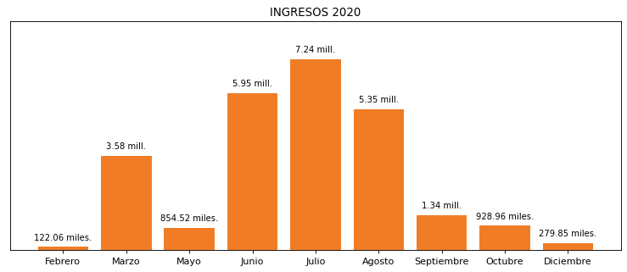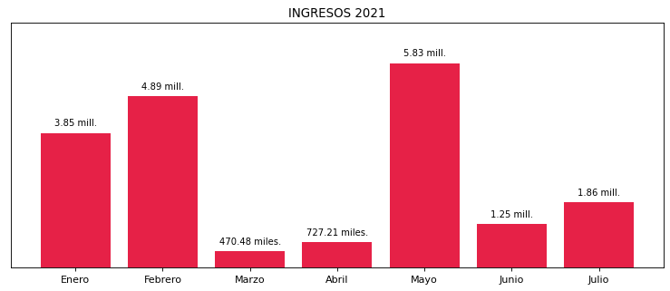

|  |
| --- |
| **EMPAQUES TRANSPARENTES**  USUARIO |

|  |
| --- |
| **Edwin Torres**  Ejecutivo de cuenta |

|  |
| --- |
| **0**  Primera fecha: PUNTO FOCAL |

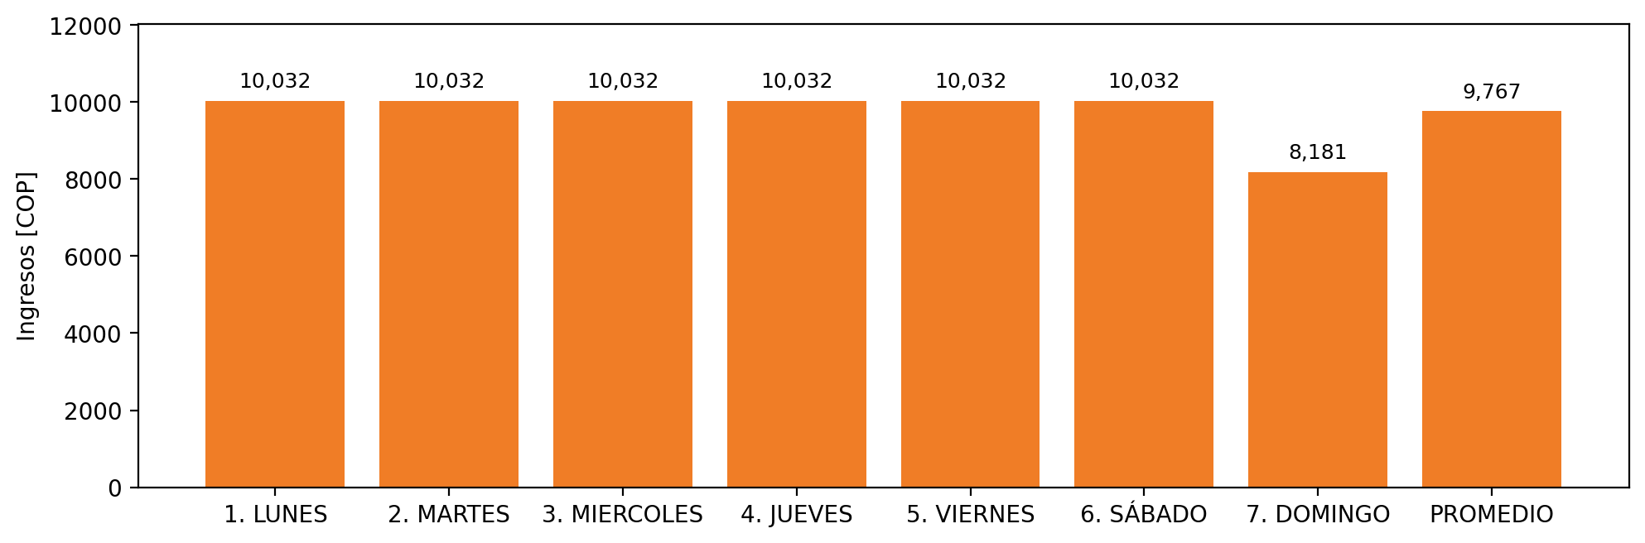

|  |  |  |  |  |  |  |  |  |  |
| --- | --- | --- | --- | --- | --- | --- | --- | --- | --- |
| **FRONTERA COMERCIAL** | **TIPO DDV** | **COD SIC** | **PREDIO** | **PROMEDIO** | **MARGEN** | **ÚLTIMA DESCONEXION** | **DÍAS CERTIFICADOS** | **ACTUALIZACION** | **PROXIMA PRUEBA DDV** |
| EMPAQUES TRANSPARENTES LTDA. | Frt36400 | Frt01097 | Prd01576 | 9,767 | 11,48 | 2020-12-24 | 89.0 | 2021-11-25 | 2021-11-29 |